DAY 1 — FINAL DOCUMENTATION
Monday, 19 October 2026
Prepared by: Abhishek

1. Executive summary
On Day 1, Abhishek documented the microservices architecture and key integration contracts, improved Order Service validation error handling, exercised the order-creation and confirmation flow, inspected distributed tracing in Jaeger, and committed the completed project updates. The recorded results show that valid order creation, invalid-quantity rejection, order retrieval after confirmation, and end-to-end trace visibility were exercised successfully.

2. Objectives and work completed
Workstream | What was done | Why it matters
Service boundaries | Created `docs/service-boundaries.md` to document service responsibilities and boundaries. | Makes ownership and service responsibilities easier to understand and reduces accidental coupling.
Order API contract | Created `docs/contracts/order-api.yaml`. | Provides a concrete API contract for consumers and future integration/testing.
Kafka event documentation | Created `docs/kafka-events.md` to record the asynchronous event topics used by the system. | Clarifies event names and supports consistent producer/consumer integration.
Architecture and trust boundaries | Created `docs/architecture-trust-boundaries.mmd` and included the architecture diagram in this report. | Makes synchronous calls, asynchronous messaging, persistence ownership, and trust boundaries reviewable.
Order error handling | Replaced/updated Order Service `GlobalExceptionHandler.java` so invalid quantity is reported as HTTP 400. | Returns a client-appropriate validation response instead of treating invalid input as an unexpected server failure.
Order workflow validation | Created an order successfully, then verified that the order reached `CONFIRMED` after the payment-completed flow. | Checks more than the initial HTTP response: it exercises the asynchronous business lifecycle.
Distributed tracing | Opened Jaeger and observed a trace containing Gateway, Order, User, Inventory, Payment, and Notification service activity. | Provides visibility across service boundaries when investigating latency or failures.
Version control | Committed updates as `51f3f82` with message `chore: save project updates and documentation`. | Preserves the work in version control and makes the change set identifiable.

3. Architecture overview
The supplied diagram shows an external client entering through the API Gateway (port 8080), which routes requests to the internal HTTP services. The Order Service (port 8082) is marked with idempotency and outbox responsibilities; Product, Payment, and User are separate services. Inventory and Notification participate in event-driven processing. Apache Kafka carries business events, service-owned databases are shown separately, and Redis holds shared state such as rate-limit counters and idempotency state. The diagram also labels trust boundaries and correlation IDs.
This description explains the supplied architecture diagram; it does not claim that every depicted connection or mechanism was independently tested on Day 1.
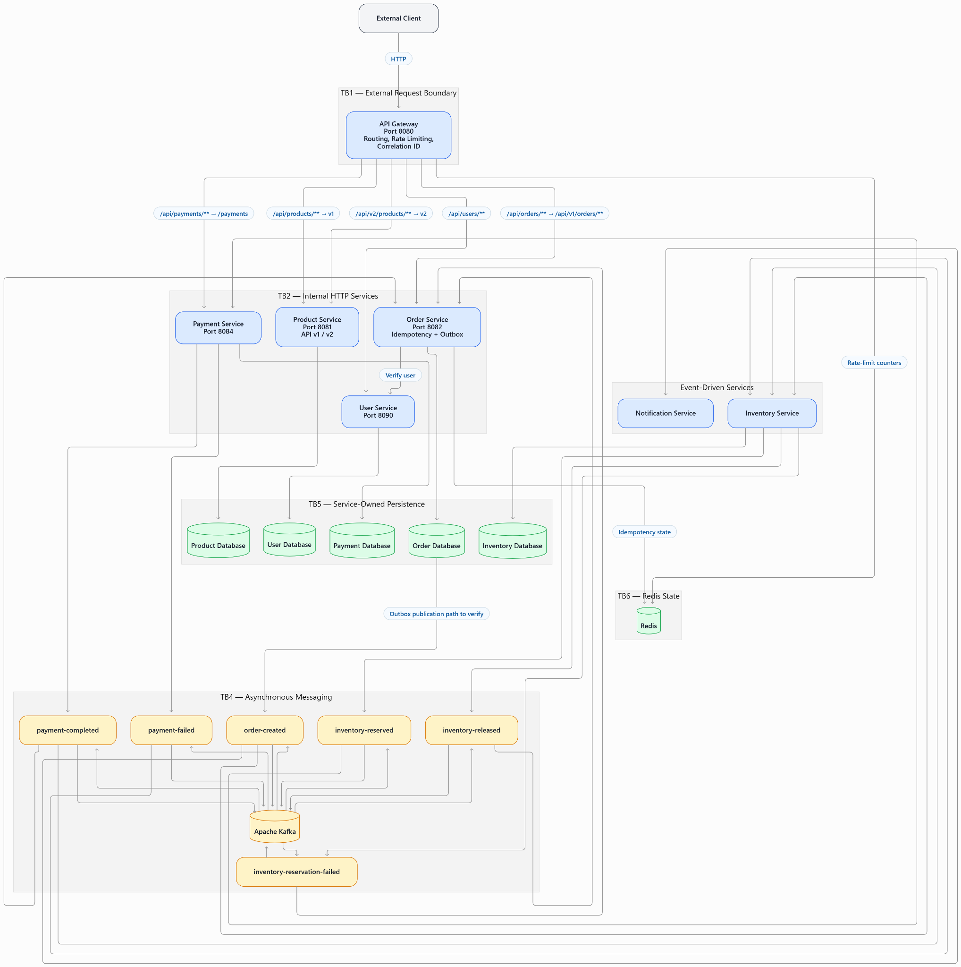
Figure 1. Project architecture and trust-boundary diagram supplied for the Day 1 report.

4. Tests performed and results
Test / verification | Observed result | Review outcome
Create a valid order | POST `/api/orders` returned HTTP 201 Created. | Passed — order creation request was accepted.
Reject invalid quantity | Invalid quantity returned HTTP 400 Bad Request after the Order Service exception-handler update. | Passed — invalid client input was rejected with a 4xx response.
Retrieve confirmed order | GET `/api/orders/16445` returned HTTP 200 OK and status `CONFIRMED`. | Passed — persisted order state was retrievable after confirmation.
Observe payment/order event flow | Order Service logs indicated `payment-completed` and order confirmation. | Observed — logs supported the successful lifecycle result.
Inspect distributed trace | Jaeger trace showed activity across Gateway, Order, User, Inventory, Payment, and Notification. | Passed as a trace-visibility check; not a substitute for automated assertions.
Check repository state | Commit `51f3f82` was reported, with a clean working tree and origin/master synchronization. | Recorded — version-control state was reported as clean and synchronized.

5. Code and documentation changes
Files and artifacts recorded as created or updated:
- `docs/service-boundaries.md` — service responsibility and boundary notes.
- `docs/contracts/order-api.yaml` — Order API contract.
- `docs/kafka-events.md` — Kafka event/topic documentation.
- `docs/architecture-trust-boundaries.mmd` — architecture/trust-boundary diagram source.
- Order Service `GlobalExceptionHandler.java` — improved handling for invalid quantity, verified by HTTP 400.

6. What I learned
- A microservices architecture needs explicit service boundaries and API/event contracts; service names alone do not explain integration expectations.
- Synchronous HTTP calls and asynchronous Kafka events are different interaction styles and should be documented separately.
- An HTTP success when creating an order does not by itself prove the complete business workflow succeeded; the order’s later state and service logs also matter.
- Validation failures should be represented as client errors such as HTTP 400, while unexpected failures should not be disguised as validation errors.
- Distributed tracing helps connect work across multiple services using a shared trace/correlation context.
- A clear Git commit makes a day’s work reviewable and recoverable.

7. Completion statement
Day 1 was completed on Monday, 19 October 2026. The work included the documentation updates, Order Service validation error-handling change, manual verification of the order workflow, and distributed-trace inspection described in this report.

